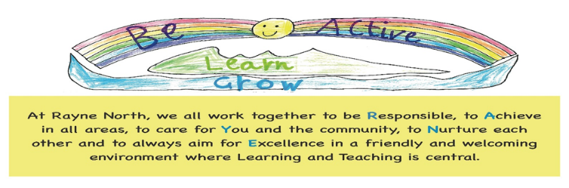
Internet, Mobile Device, Social Media and Mobile Phone Acceptable Use
At Rayne North School we have access to the internet through laptops, chrome books and iPads. These are used in a variety of ways to support learning and teaching.
This may be through the use of specific apps, educational websites or through the build-up of typing and word processing and tech skills such as the use of email, saving work creating presentations, using spreadsheets and coding.
All children and adults in the school are allocated individual logins which allow access to our devices and the internet through Glow Scotland the Education Scotland supported intranet system.
All devices used to support learning in the school are purchased through local authority procurement system and are built to meet the schools needs and can be accessed and monitored centrally by the council IT department.
The supervision level within school and the quantity of quality material available to support learning within the internet gives a position where we feel education regarding the risks allows us to focus and gain from the positives of the internet.
Technology is encouraged within school and safety messages around the possible risks are shared with children in an age appropriate way as they move through the school.
This can also be further reinforced by our code club which builds IT skills in an out of school club run by staff and parents.
Internet Use
In the early years use of the internet will be strongly directed by and supervised by staff. As the children move through the school they will begin to have more independence and use technology to support research, presentation creation, coding and interact more independently with devices in a supervised classroom environment. This will always be at times directed by class teachers and with a focus on supporting learning.
Throughout the internet safety messages are shared through school assemblies, class discussions, use of CEOP resources and inputs from our school police liaison officer. The school will also share any information it feels relevant with parents to support positive interaction with technology and the internet at home. This may be information on new games or apps children are interested in and the potential dangers to look out for.
Parents will sign their agreement with this when enrolling their child at Rayne North School.

The main internet safety messages shared with pupils throughout school are;
- People you do not know are strangers and they may not always be who they say they are
- Remember not everything you read or see on the internet is true
- Be respectful to people online as you would be in real life
- Keep your personal information private online
- Do not share your log in and password details
- If you are ever unsure ask an adult
As the children move through the school they will discuss and be aware of more detailed messages such as;

- I will only send emails to people I know or who are approved by my teacher. I will never forward chain emails.
- I will only use my official school or Glow account to send or receive emails on my mobile device. I will ensure that any emails or blog posts are polite, sensible and responsible.
- I understand that the school can and will check my files, emails, blog posts and visited websites to ensure that I use my mobile device and the Internet safely and properly. I will show my teacher my mobile device upon request.
- I will only copy and use material as permitted by copyright legislation and will ask if I am unsure. I will not use my device to share copyrighted files.
- I will not delete my search or website history in my Internet browser unless directed
Educational Sites and Apps
The school will make use of a number of educational sites and apps to support learning. These will be directed by staff and be sites deemed appropriate by Aberdeenshire Council. Rayne North School currently accesses SumDog, Nessy Learning, Accelerated Reader and Study Ladder. Your child will have an individual log in for these sites and these will be monitored by school staff.

Mobile Phones
There may be occasions where a mobile phone may be allowed in school for a specific purpose this will be communicated by staff.
Our default position remains that if you need to contact your child during school hours or they need to contact you this will be done through the school office.
We are aware there may be occasion they are going to a different location after school and may require a mobile phone in school. In this case we would ask;
- Devices are switched off in school and either left in bags or safely on the teachers desk for the duration of the school day
- It should be noted that;
- If a pupil is found using a phone in the school building or playground throughout the day it will be removed and stored in the school office. Parents will be contacted.

- If a pupil is found taking photographs or videos of pupils of staff this will be considered a serious discipline issue and be dealt with by the HT. In certain circumstances this may be taken further. A device would be returned once recordings and images had been removed by a parent or guardian.
- The school has no liability for the loss or damage of any mobile phone brought to school and this is done at personal risk.

Social Media
Social Media is a large part of society and children will come into contact with this as they grow older.
Social media sites are not used in classrooms.
The school has a twitter account for parents which is updated by staff and any references to pupils is only after relevant permission is sought from parent or guardian.
Across the country there have been some incidences where negative messages and inappropriate comments have been made on social media and highlighted in the press.
It is the responsibility of everyone in the Rayne North community to treat each other with respect and deal with all situations in a respectful manner regardless of the platform or setting.
This message along with the age restrictions and risks of sites will be addressed in our age appropriate teaching with the pupils regarding online presence and internet safety.
Parents, Carers and visitors to school events should always be mindful that any photos taken are not posted on social media pages.

Helpful Links

https://nationalonlinesafety.com/guides

https://www.thinkuknow.co.uk/parents/Support-tools/presentations-for-parents/

https://www.saferinternet.org.uk/

Review Date 2022

