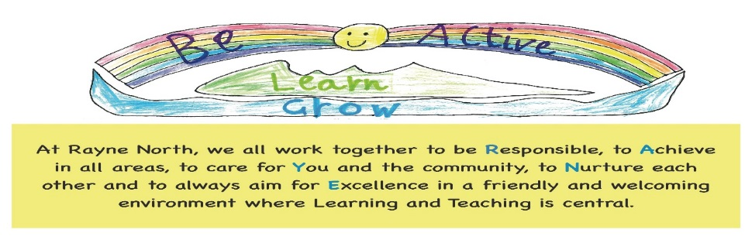
Promtoting Positive Behaviour (Including Anti Bullying)
Policy

For the purposes of this policy parent refers to parent, guardian or carer.

1 Introduction
The purpose of this policy is to ensure staff, parents, pupils and the wider community have a shared understanding and can work together to promote positive behaviour.
High standards are expected from everyone associated with Rayne North School Community.
As a school community we strive to work together to develop a caring and considerate environment.
We have considered the UNCRC. Article 28 states, “discipline in schools should maintain children’s dignity”.
Consideration has also been given to GIRFEC, Restorative Practice, Aberdeenshire Policies, Education Scotland and the school Vision, Values and Aims.
Self-discipline is at the centre of learning and pupils are encouraged to be responsible for their choices. Considering what the right choice is, what the wrong choice would be and consequently what the better choice would have been.
It is also important that all adults in the school community set a good example for our children and treat each other with courtesy and respect.

“Developing good relationships and positive behaviour in the classroom, playground and wider community is essential for creating the right environment for effective learning and teaching. Where children and young people feel included, respected, safe and secure and when their achievements and contributions are valued and celebrated, they are more likely to develop self-confidence, resilience and positive views about themselves. This applies equally to all staff in the learning community.”
Education Scotland - Better Relationships, Better Learning, Better Behaviour
Where possible the policy will be applied to all however we will also be mindful that the needs of the individual may require flexibility, further planning and understanding to ensure equity.
“Fair isn’t everyone getting the same, Fair is everyone getting what they need in order to be successful.”
2 School Expectations
The school vision and underpinning values deliver a shared expectation for the behaviour of all and should be exemplified in interactions throughout the school.
These will be reinforced by a whole school charter which has positive simple and concise messages related to our values to follow.
Under this umbrella there will be individual classroom based charters to support the daily management of individual classes at an age appropriate level. These will be referred to and refreshed regularly.
Rayne North School Vision
Be Active, Learn, Grow
At Rayne North, we all work together to be Responsible, to Achieve in all areas, to care for You and the community, to Nurture each other and to always aim for Excellence in a friendly and welcoming environment where Learning and Teaching is central.
Rayne North School Values |  | Rayne North School Charter
Respect and Respecting Others | Positivity and Openness | Look After Things | Have Courage
Ambition and Achievement in all areas | Responsibility and Trustworthiness | Be Generous and Supportive | Be Positive
Confidence and Feeling Safe | Inclusion and Our Community | Try Your best | Respect Everyone Including Yourself
Friendliness and Nurturing Others | Motivation and Active Involvement

3. Rayne North School Promotes Positive Behaviour by;
- Using verbal praise and encouragement
- Individual classroom management strategies e.g. table points, choosing time, stickers, achievements wall, visual timetable, target charts
- Assembly Focus
- Vision and Values themed certificates
- House Points
- Health and Wellbeing Curriculum – Bounce Back, Cool in School
- Give responsibilities through buddy systems
- House captains
- Whole school interaction – house events, paired reading
- Providing positive role models through showing consideration, good manners and respect for children and adults
- Having an understanding of stage / age appropriate behaviour
- Differentiating between deliberate and accidental
- Being fair and consistent
- Where appropriate being aware of individual need and triggers
- Where appropriate being aware of the need for Individual Education Plans
- Where appropriate being aware of the need to access support strategies such as Intervention Prevention Teacher and Pupils Support Worker
4. Rayne North School Staff will;
- Maintain classroom behaviour management strategies in a fair and consistent way
- Praise, encourage and role model
- Carry out Health and Wellbeing curriculum work on social, mental and physical health
- Liaise with the HT if day to day classroom management strategies do not meet an individual’s needs
- HT and CT liaise with parents to address individual needs if appropriate
- Seek parental permission to consult external agencies if appropriate

5. Rayne North School Parents will;
“..parents and carers are key partners in their children’s learning. It’s vital that schools engage directly with parents and carers and foster a positive environment where parents and carer are encouraged to work in partnership to ensure where possible a consistent message between the home and school environment”.
Education Scotland – Better Relationships, Better Learning, Better Behaviour
- Ensure pupils are aware of class charters
- Support awareness of how actions can impact others
- Display a willingness to work with school to maintain positive relationships, uphold behaviour and support decisions to address individual need
- Support a positive attitude to school encouraging rest, preparation and organisation for a day of learning
- Engage in multi-agency planning or support mechanism established as a result of individual need
6. Rayne North School Pupils will;
- Display a positive, can do attitude
- Treat others with respect
- Listen to others
- Allow others to feel safe
- Follow the school and class charters
- Provide positive role models for their peers
- Seek support in situations where others require assistance
7. Rayne North School - Responses to Behaviour
- Respond calmly
- Listen to all involved in situations and give time to share views
- Deal sensitively with situations
- Treat situations fair and consistently
- Make clear which behaviours have not been acceptable
- Look at alternative ways of having dealt with situations
- Look at the impact of behaviours on all involved

8. Rayne North School - Processes in Behaviour Management
Most incidents will be dealt with by a member of school staff at the time through classroom management strategies which indicate next steps.
Where this does not resolve the matter the issue will be escalated to the HT, where the following may take place:
- Restorative conversation with the child/ren
- Reflective time away from others during play or choosing time
- Contact with parent to discuss situation
- Professional discussion between HT and CT of approaches, strategies and next steps
After this if needs are not addressed next steps would be
- Individual Behaviour strategies such as Target Charts, Regular Home/School Meetings, Home/School Daily Diary, Individual Education Plan, Risk Assessments
- Involvement of Intervention Prevention Teacher, Pupils Support Worker, School Doctor, External Agencies and Educational Psychologist may also be considered
9. Bullying
Bullying takes place when the persistent actions of an individual or group of people cause harm to someone by taking advantage of an imbalance of power within a relationship. Bullying behaviour is abusive.
Bullying behaviour is often displayed as a result of past experiences which affect and impact on current actions.
Bullying can be verbal, physical, emotional or cyber. People who experience bullying behaviour feel vulnerable and/or socially isolated.
- When someone says or does something unintentionally hurtful and they do it once that is RUDE.
- When someone says or does something intentionally hurtful and they do it once that is MEAN.
- When someone says or does something intentionally hurtful and they keep doing it even when you tell them to stop or show them you’re upset that is BULLYING.
Rayne North’s stance is that Bullying is unacceptable.

We as parents, pupils and staff will work together to promote positive behaviour, maintain high expectations and respect for others.
As a school we will raise awareness of what bullying is through learning and teaching.
Most incidents will be dealt with through good home/school relationships and behaviour management approaches.
10 Rayne North School – Persistent Sudden and Extreme Behaviour
On rare occasions a child may display behaviour that disrupts normal functioning of the school. This will immediately be referred to the Head Teacher. The Head Teacher and the class teacher will investigate, notify parents and where appropriate log the incident.
If appropriate in persistent situations the involvement of cluster support systems, external agencies and detailed individual plans may be utilised.
In some circumstance the incident may be so serious as to warrant exclusion either on a short term or conditional basis in line with Aberdeenshire policies.

Policy created through staff, parent and pupil consultation – February 2018
Policy review – February 2021

