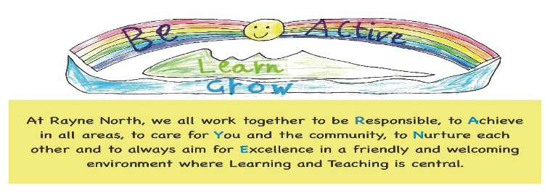

Child Protection Policy

Context

Protecting children and young people and meeting their needs is everyone’s job. We're all responsible for reporting concerns about a child's welfare

Aberdeenshire Guidelines for protecting children and young people form part of every employee’s Terms and Conditions of Service and therefore apply to all staff and to all working activities at Rayne North School.

The Guidelines which will be adhered to by all members of staff are based on the national guidelines which are set within the wider context of GIRFEC, The Early Years Framework and the UN Rights of the Child and set out common standards for protecting children through interagency working.

National and Local Guidelines
National guidelines can be accessed at http://nspcc.org.uk/scotland , http://www.girfec-aberdeenshire.org/wp-content/uploads/2015/03/National-Guidance-for-Child-Protection-in-Scotland-2014.pdf while North East of Scotland Child Protection Guidelines can be found online at http://www.childprotectionpartnership.org.uk and Aberdeenshire’s policy guidelines at www.girfec-aberdeenshire.org
Staff should also use the CEOP website at http://ceop.police.uk to access information about internet safety. All three websites should be referred to for guidance and advice. NESCP also provide a range of training opportunities for staff.

Training
The Head Teacher has undertaken Aberdeenshire and NESCP training in GIRFEC and Child Protection.
Staff responsible for Child Protection will continue to update their knowledge and understanding through ongoing training.

Personnel
At Rayne North School the Head Teacher Stephanie Stephen is the Child Protection Co-ordinator and has overall responsibility for all matters of child protection. In her absence a member of teaching staff will take on this responsibility. The teaching staff can seek support from nearby Head Teachers if required in the Head Teachers absence.
- Mrs E McMahon Logie Durno School 01467 536900
- Mr J Ferguson Rayne North School 01464 851213
Staff members with any concerns relating to a child at risk from any form of abuse should immediately discuss their concerns with the Child Protection Co-ordinator. A GC1 should be completed (link attached at end of policy).
The Child Protection Co-ordinator will contact Social Work and Police as appropriate.
Social Work and/or Police will provide advice, and discuss what further action is needed. They will decide whether to hold an Initial Referral Discussion (known as an IRD) which helps decide whether a child protection investigation is required. Aberdeenshire's IRD guidance is available on the GIRFEC website.

Staff Responsibility

It is the responsibility of every staff member to have read, understood and follow national and local guidelines (see websites under National/Local Guidelines). Staff will be informed and updated on an annual basis on the School’s Child Protection Guidelines. New staff, students and volunteers will also be informed of policy and procedures when they join the school.

Be Aware!

Research tells us disabled children are approximately 3.6 times more likely to be abused or neglected than non-disabled children. Disabled children are particularly vulnerable to abuse and neglect, because they are more dependent on parents and carers to have their needs met.
Children with communication difficulties may not be so able to tell anyone about their situation. Some children may not understand that what is happening to them is abuse or neglect.

The categories of abuse are; Physical Abuse, Emotional Abuse, Sexual Abuse and Neglect.

The indicators of risk include Domestic Abuse, Parental Substance Misuse, Parental Alcohol Misuse, Parental Mental Health, Sexual Abuse, Physical Abuse, Emotional Abuse, Non-engaging family, Child Placing Self at Risk, Neglect, Child Sexual Exploitation, Trafficking, Female Genital Mutilation and Forced Marriage.

Three Key Questions
- Is this child or young person at immediate risk?
- What is placing this child at immediate risk?
- What needs to happen to remove this risk now?
If the answer to the first question is yes, Child Protection protocols must be followed immediately. Aberdeenshire Education Protocol Flow chart is attached to this policy.

The Head Teacher has responsibility for ensuring that any referrals are dealt with in line with Aberdeenshire and National Guidelines. They should also ensure that staff are supported and supervision provided throughout the process.

Child Protection Records

Where information on Child Protection is held in school, the child’s file will be marked with a blue dot. Confidential Child Protection information will be kept in a locked cupboard in the Head Teacher’s office and can only be accessed through the Head Teacher.

Annual Actions

Each year Rayne North School will publish information through the parent handbook making parents aware of the school’s Child Protection Guidelines. In particular this will make parents aware that in situations where there is a possibility that a child could be at risk of abuse or neglect, the school is required to refer the child to Social Work, the Police or the Children’s Reporter and that under these circumstances, the parents would not normally be consulted first.

As part of the August In-Service Day staff will be reminded of the Child Protection policy and procedures, including any updates from local/national guidelines.

GC1 FORM LINK
https://aberdeenshire.sharepoint.com/sites/Arcadia/services/Documents/Education%20and%20Children's%20Services/Education%20And%20Learning/Child%20Protection/GC1-FINAL.docx

Further Information and Advice

- Protecting Children in Aberdeenshire 3 Booklets for Schools on Arcadia
- Reporting Child protection Concerns – Initial Referral Discussions
- National Child Protection Guidelines (2014)
- Aberdeenshire GIRFEC website Child Protection Section
- Aberdeenshire Multi Agency Learning & Development Child Protection Training Calendar

- Support offered by Speech and Language Therapy.dooffered cx
- Guidance for supporting children during the child protection process.docx
- Support for children and young people once the initial stages of the investigation are completed.docx
- Aberdeenshire Support Manual – For children with a range of ASN

Policy Reviewed: August 2018
Review Date: August 2020

