

**RAYNE NORTH SCHOOL**

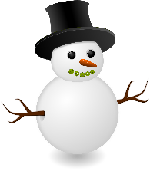



**Winter Snow Closure Pack Class 3**

* Create a Snow sculpture and photograph or draw it.
* Go sledging – what position can you sit in to make the sledge go faster?
* Make a hot chocolate for you and a friend.
* Read a good book.
* Clear a path in the snow for a family member or a neighbour.
* Feed the birds.
* Make lunch for you and your family.
* Learn a times table you find difficult.
* Read a good book.
* Do an activity on My Maths or Study Ladder.
* Watch the news with an adult.
* Log on to Glow to check for messages from your teacher or classmates.
* Watch a film you have always wanted to watch.
* Bake a cake or some cookies.
* Make a list of things that make you happy.
* Tell a friend or family member a story you have made up.
* Talk to an adult about the topics they covered when they were in school.
* Ask an adult to give you a job in the house to do.
* Practise your throwing skills by throwing snowballs at a safe target.
* Go icicle hunting.
* Look in the snow for any animal or bird tracks.
* Plan and cost for an ideal party for Class 3.
* Sing a favourite song and make up a dance for it.
* Make up a general knowledge quiz and see if an adult know the answers.
* Remember to have fun in the snow and come back with lots of news to share your classmates.